NOTICE OF PUBLIC HEARING
September 4th, 2025, 6:30 PM

The Murray City Planning Commission will hold a public hearing in the Murray City Council Chambers, located at 10 East 4800 South to receive public comment on the following application:
Claudia Alvarado has applied for a zone map amendment for the property located at 6446 South 900 East. The applicant is requesting a Zone Map Amendment from R-1-8, Low Density Single Family Residential to R-N-B, Residential Neighborhood Business. The requirements of the zone are located on our website at www.murray.utah.gov. The Planning Commission will be making a recommendation to the City Council for this item. The City Council will conduct another Public Hearing to make a decision regarding this application at a later date.
To make comments regarding this proposal the public may attend the meeting, call Murray City Planning Division at (801) 270-2430, or email pc@murray.utah.gov. You have received this notice because you own property within 300 feet of the subject property.
The meeting will be streamed online, at www.murraycitylive.com or www.facebook.com/MurrayCityUtah/.
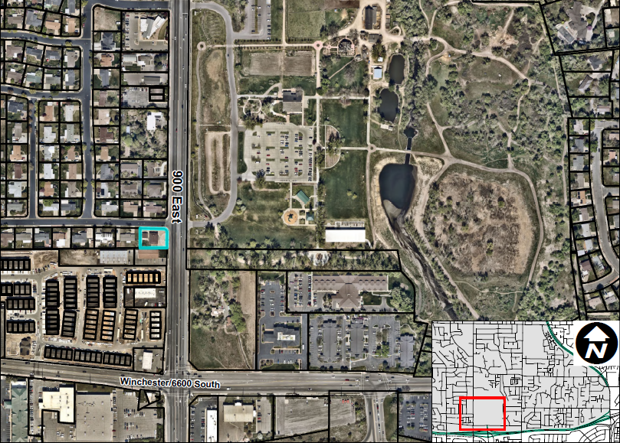
Subject Property

Special accommodations for the hearing or visually impaired will be upon a request to the office of the Murray City Recorder
(801-264-2660). We would appreciate notification two working days prior to the meeting. TTY is Relay Utah at #711

