PUBLIC NOTICE IS HEREBY GIVEN that the Board of Directors of the Redevelopment Agency of Murray City, Utah will hold a regular meeting Tuesday, July 5, 2022 in the Murray City Council Chambers at 5025 S. State Street, Murray, UT.

Any member of public may view the meeting via the live stream at www.murraycitylive.com or https://www.facebook.com/Murraycityutah/.

Public Comments can be made in person during the meeting or may be submitted by sending an email (including your name and address) to: rda@murray.utah.gov All comments are limited to 3 minutes or less and email comments will be read into the meeting record.

RDA MEETING AGENDA
Tuesday, July 5, 2022

THERE WILL BE NO RDA MEETING TUESDAY, JULY 5, 2022

Special accommodations for the hearing or visually impaired will be made upon a request to the office of the Murray City Recorder (801-264-2660). We would appreciate notification two working days prior to the meeting. TTY is Relay Utah at #711.

On July 1, 2022, a copy of the foregoing Notice of Meeting was posted in accordance with Section 52-4-202 (3).
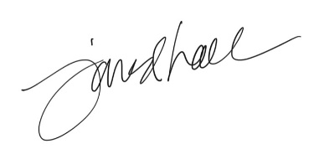

_______________________________________
Jared Hall,
RDA Deputy Executive Director

