
Murray City Municipal Council
Notice of Meeting
Wednesday, September 25, 2019
Home 2 Suites 4927 South State Street
Murray, Utah 84107

City Council Workshop

Agenda

12:30 p.m. Home 2 Suites Conference Room

- Welcome/Introductions Dave Nicponski, Council Chair

- Overview Power Financial Policy Diane Turner, Budget & Finance Chair

- Webinar: Utility Financial Solutions, LLC by Dawn Lund
- Current Power Fund Financial Standards
Murray City Municipal Code 15.20.260
- Discussion

- Resource Synopsis and Future Plans Blaine Haacke, Power General Manager

- Adjournment

On Monday, September 23, 2019, at 1:30 p.m., a copy of the foregoing notice was posted in conspicuous view in the front foyer of the Murray City Center, Murray, Utah. Copies of this notice were provided for the news media in the Office of the City Recorder. A copy of this notice was posted on Murray City’s internet website www.murray.utah.gov. and the state noticing website at http://pmn.utah.gov .

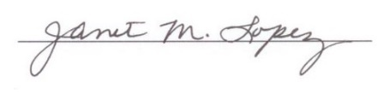

Janet M. Lopez
Council Executive Director
Murray City Municipal Council

